how to Scheduled daily/weekly/monthly tasks in multi-cloud operation using (Logic Apps +Automated Runbooks)

To schedule daily, weekly, or monthly tasks in a multi-cloud operation using Azure Logic Apps and Automated Runbooks, follow these detailed steps:

**Step 1: Set Up Azure Logic Apps**

* **Create a Logic App**:
  + Go to the Azure Portal.
  + Click on "Create a resource" and select "Logic App".
  + Provide the necessary details like name, subscription, resource group, and location.
* **Design the Workflow**:
  + Once the Logic App is created, open the Logic App Designer.
  + Start with a trigger. For scheduling tasks, use the "Recurrence" trigger.
  + Configure the recurrence settings:
    - **Daily**: Set the frequency to "Day" and specify the interval (e.g., every 1 day).
    - **Weekly**: Set the frequency to "Week" and choose the specific days of the week.
    - **Monthly**: Set the frequency to "Month" and specify the day of the month.

**Step 2: Integrate Automated Runbooks**

* **Create an Azure Automation Account**:
  + In the Azure Portal, create an Automation Account where your runbooks will reside.
  + Provide necessary details like name, subscription, resource group, and location.
* **Create a Runbook**:
  + Within the Automation Account, create a new runbook.
  + Choose the type of runbook (e.g., PowerShell, Python).
  + Write the script that performs the desired task. This could be anything from managing resources in Azure to interacting with other cloud services.
* **Publish the Runbook**:
  + Test your runbook to ensure it works as expected.
  + Once tested, publish the runbook to make it available for execution.

**Step 3: Connect Logic Apps to Runbooks**

* **Add an Azure Automation Action**:
  + In the Logic App Designer, after the "Recurrence" trigger, add an action.
  + Search for "Azure Automation" and select "Create job" or "Start a runbook".
  + Configure the action to specify the Automation Account and the runbook you want to execute.
* **Pass Parameters (if needed)**:
  + If your runbook requires parameters, you can pass them from the Logic App. This allows dynamic execution based on the Logic App's workflow.

**Step 4: Multi-Cloud Integration**

* **Use Connectors**:
  + Logic Apps provide connectors for various cloud services like AWS, Google Cloud, and others.
  + Add actions to interact with these services as needed. For example, you can use AWS S3 connectors to manage files or Google Cloud connectors for data processing.
* **Custom APIs**:
  + If specific cloud services do not have built-in connectors, consider creating custom APIs or using HTTP actions to interact with those services.

**Step 5: Monitor and Manage**

* **Monitor Logic Apps**:
  + Use Azure Monitor to track the execution of Logic Apps and troubleshoot any issues.
  + Set up alerts for failures or specific conditions.
* **Manage Runbooks**:
  + Regularly review runbook logs and outputs to ensure they are executing correctly.
  + Update runbooks as needed to accommodate changes in cloud environments or business requirements.

By following these steps, you can effectively schedule and manage tasks across multiple cloud environments using Azure Logic Apps and Automated Runbooks. This setup allows for flexible and scalable automation tailored to your specific operational needs.

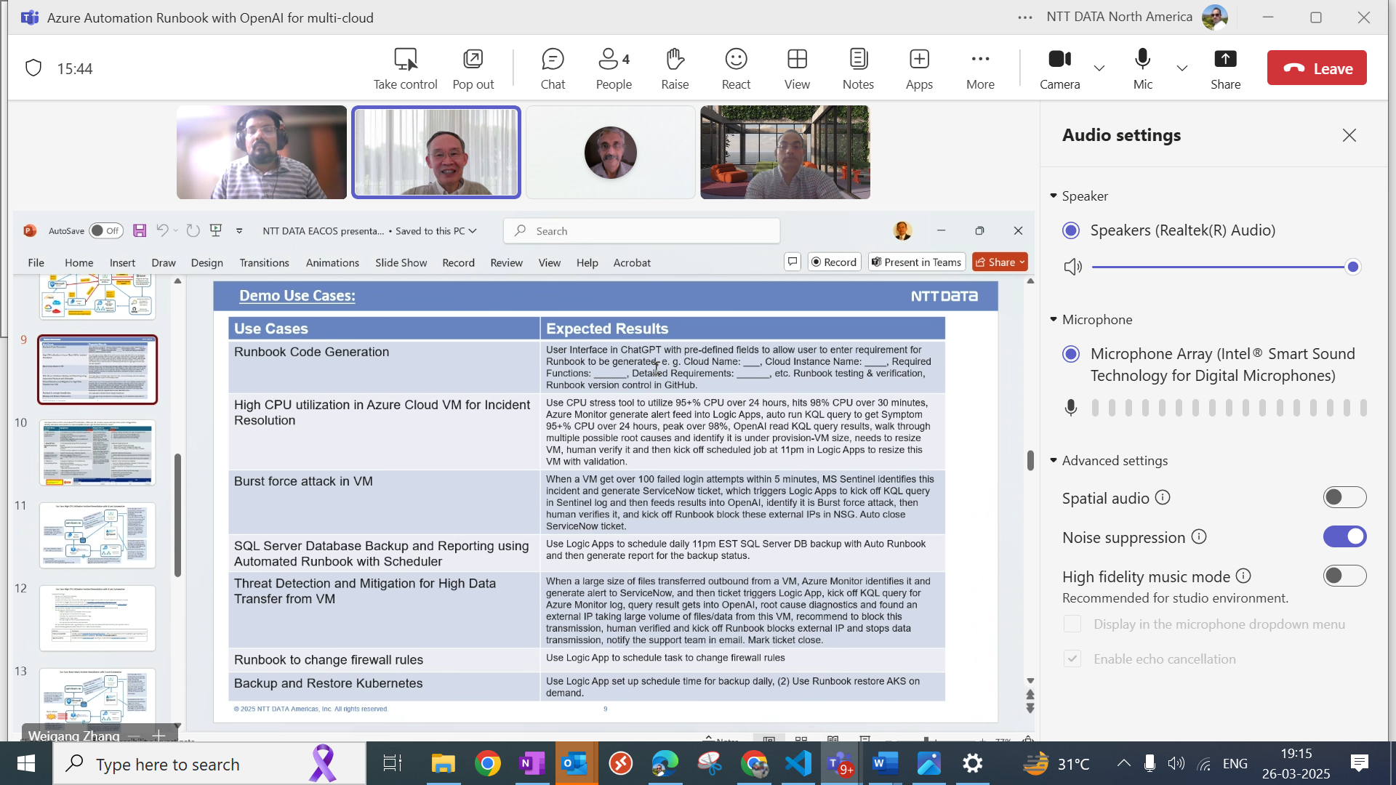

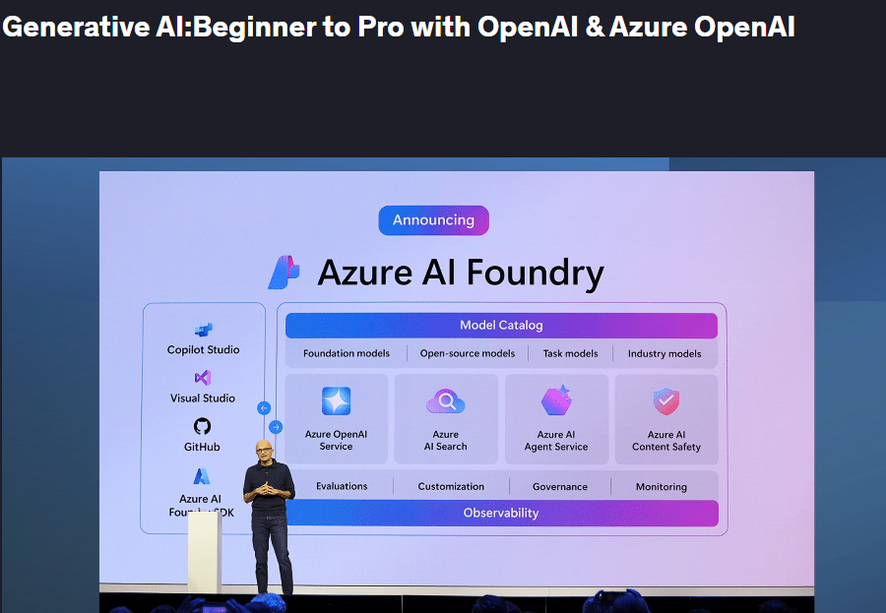

PK

how to Build Azure Workbook on OpenAI as dashboard to allow user to enter required fields to generate Runbook automatically. Then test it and put into GitHub

Building an Azure Workbook to create a dashboard that allows users to enter required fields for generating a Runbook automatically involves several steps. Here's a detailed guide to help you through the process:

**Step 1: Set Up Azure Workbook**

* **Create an Azure Workbook**:
  + Navigate to the Azure Portal.
  + Go to "Monitor" and select "Workbooks".
  + Click on "New" to create a new workbook.
* **Design the Workbook Layout**:
  + Use the workbook editor to add text, charts, and input controls.
  + Add input fields where users can enter the required parameters for the Runbook. Use the "Parameters" section to define these fields.

**Step 2: Integrate OpenAI**

* **Set Up OpenAI API Access**:
  + Ensure you have access to OpenAI's API. You'll need an API key to interact with OpenAI models.
  + In the workbook, use the "Advanced" section to add custom queries or scripts that call the OpenAI API.
* **Create Logic for Runbook Generation**:
  + Write a script that uses the input from the workbook to generate the Runbook code. This script can call OpenAI's API to assist in creating the Runbook based on user inputs.
  + Use Azure Functions or Logic Apps to handle the API calls and process the data.

**Step 3: Automate Runbook Creation**

* **Azure Automation Integration**:
  + Use Azure Automation to create and manage Runbooks.
  + Set up a Logic App or Azure Function that takes the generated Runbook code and creates a new Runbook in Azure Automation.
* **Testing the Runbook**:
  + Test the Runbook to ensure it executes correctly. Use the Azure Automation testing tools to simulate execution and check for errors.

**Step 4: Deploy and Test**

* **Deploy the Workbook**:
  + Save and publish the workbook in Azure Monitor.
  + Ensure that users have the necessary permissions to access and use the workbook.
* **Test the Dashboard**:
  + Test the entire workflow from entering data in the workbook to generating and executing the Runbook.
  + Validate that the OpenAI integration works as expected and that the Runbook is created correctly.

**Step 5: Version Control with GitHub**

* **Set Up GitHub Repository**:
  + Create a new repository on GitHub to store your Runbook code and any related scripts.
  + Use Git to clone the repository locally.
* **Push Code to GitHub**:
  + Add your Runbook code and any scripts used in the workbook to the repository.
  + Commit your changes and push them to GitHub.
* **Continuous Integration/Continuous Deployment (CI/CD)**:
  + Set up CI/CD pipelines using GitHub Actions or Azure DevOps to automate testing and deployment of Runbooks.
  + Ensure that any changes to the Runbook code are automatically tested and deployed.

By following these steps, you can build an Azure Workbook that serves as a dashboard for generating Runbooks automatically using OpenAI, test the workflow, and manage the code through GitHub. This setup allows for efficient automation and version control of your Runbooks.

**Step 3: Verification and Testing**

* **Unit Testing**:
  + Write unit tests for individual functions or modules within the Runbook. Use testing frameworks compatible with the scripting language (e.g., Pester for PowerShell).
  + Validate the logic and functionality of each component.

**Available LLM Models and Integration Options**

* **OpenAI Models via Azure OpenAI Service**:
  + Azure OpenAI Service allows you to access OpenAI's powerful language models, such as GPT-3, directly within Azure.
  + You can integrate these models with Azure Databricks by using REST APIs to call the OpenAI service from Databricks notebooks.
* **Custom LLMs with Azure Machine Learning**:
  + Azure Machine Learning provides a platform to train and deploy custom machine learning models, including LLMs.
  + You can use Azure Databricks to preprocess data and train models, then deploy them using Azure Machine Learning.
* **Pre-trained Models from Hugging Face**:
  + Hugging Face offers a wide range of pre-trained language models that can be used within Azure Databricks.
  + You can install the Hugging Face Transformers library in Databricks and load models such as BERT, GPT-2, or T5 for various NLP tasks.
* **Databricks MLflow**:
  + MLflow is integrated with Azure Databricks and can be used to manage the lifecycle of machine learning models, including LLMs.
  + You can track experiments, package models, and deploy them using MLflow within Databricks.

**Steps to Use LLMs in Azure Databricks**

* **Set Up Azure Databricks Environment**:
  + Create a Databricks workspace in Azure and configure clusters with the necessary compute resources.
  + Install required libraries, such as transformers for Hugging Face models or azure-ai for Azure OpenAI Service.
* **Access and Use OpenAI Models**:
  + Obtain an API key for Azure OpenAI Service.
  + Use Databricks notebooks to write code that calls the OpenAI API, sending text inputs and receiving model outputs.
* **Train Custom LLMs**:
  + Use Databricks for data preprocessing and feature engineering.
  + Train custom LLMs using frameworks like TensorFlow or PyTorch within Databricks notebooks.
* **Deploy Models with Azure Machine Learning**:
  + After training, deploy models using Azure Machine Learning for scalable inference.
  + Use Databricks to manage data pipelines and integrate model predictions into workflows.
* **Experiment Tracking with MLflow**:
  + Use MLflow to log parameters, metrics, and artifacts during model training.
  + Register models in the MLflow Model Registry for deployment and version control.
* 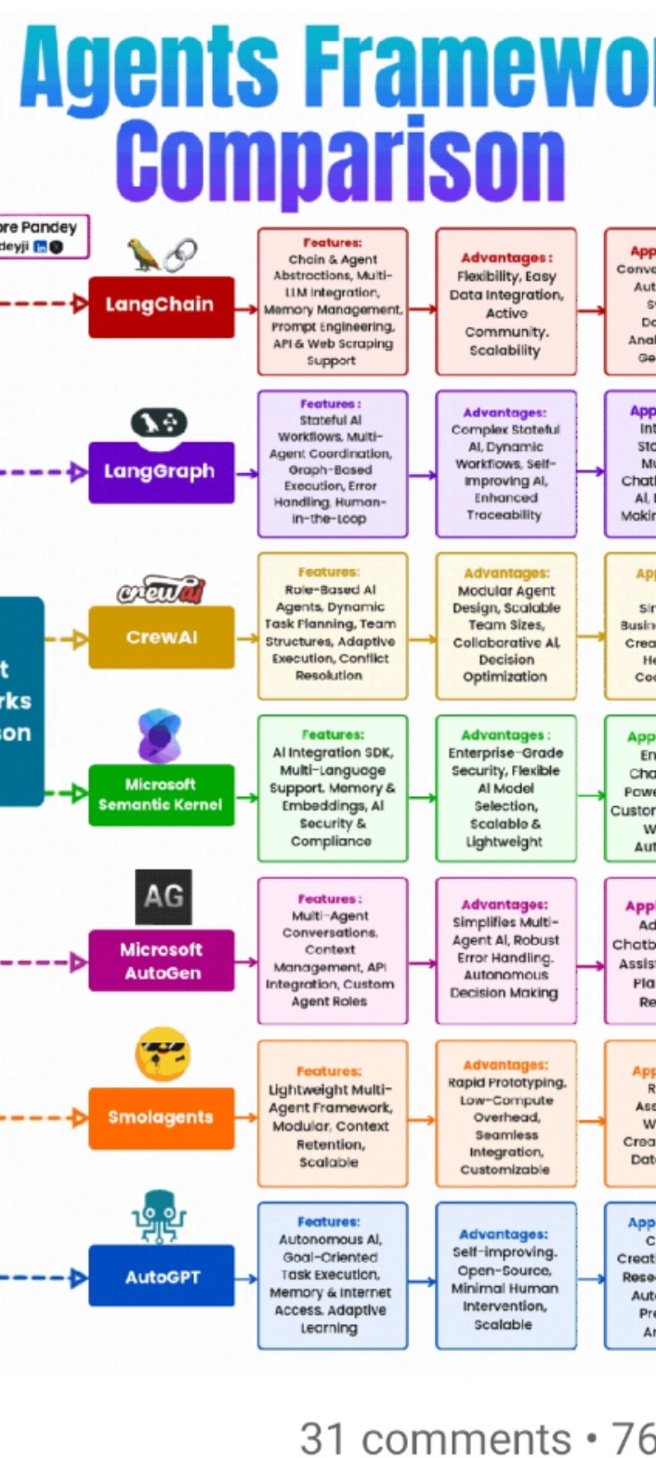

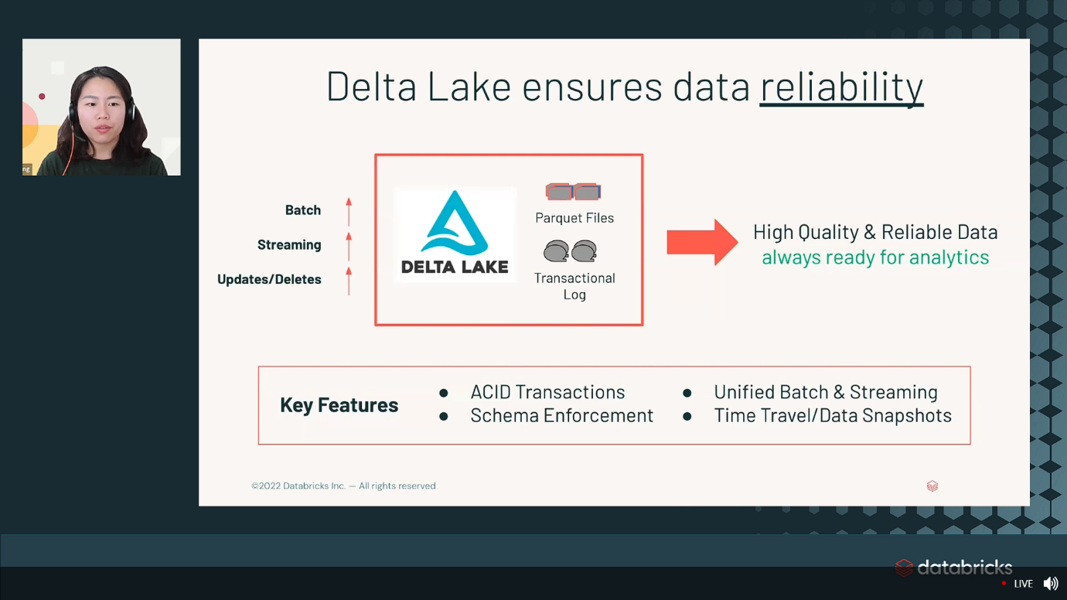

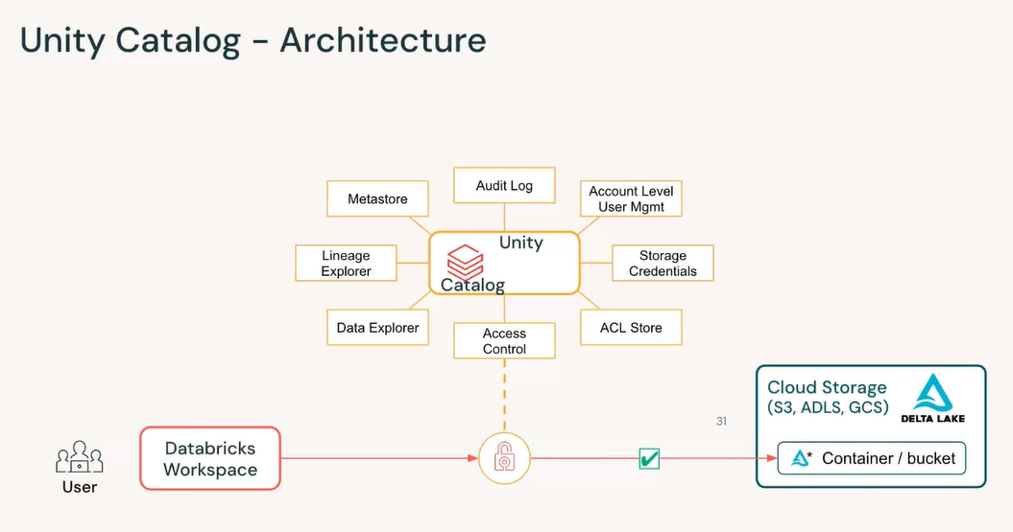

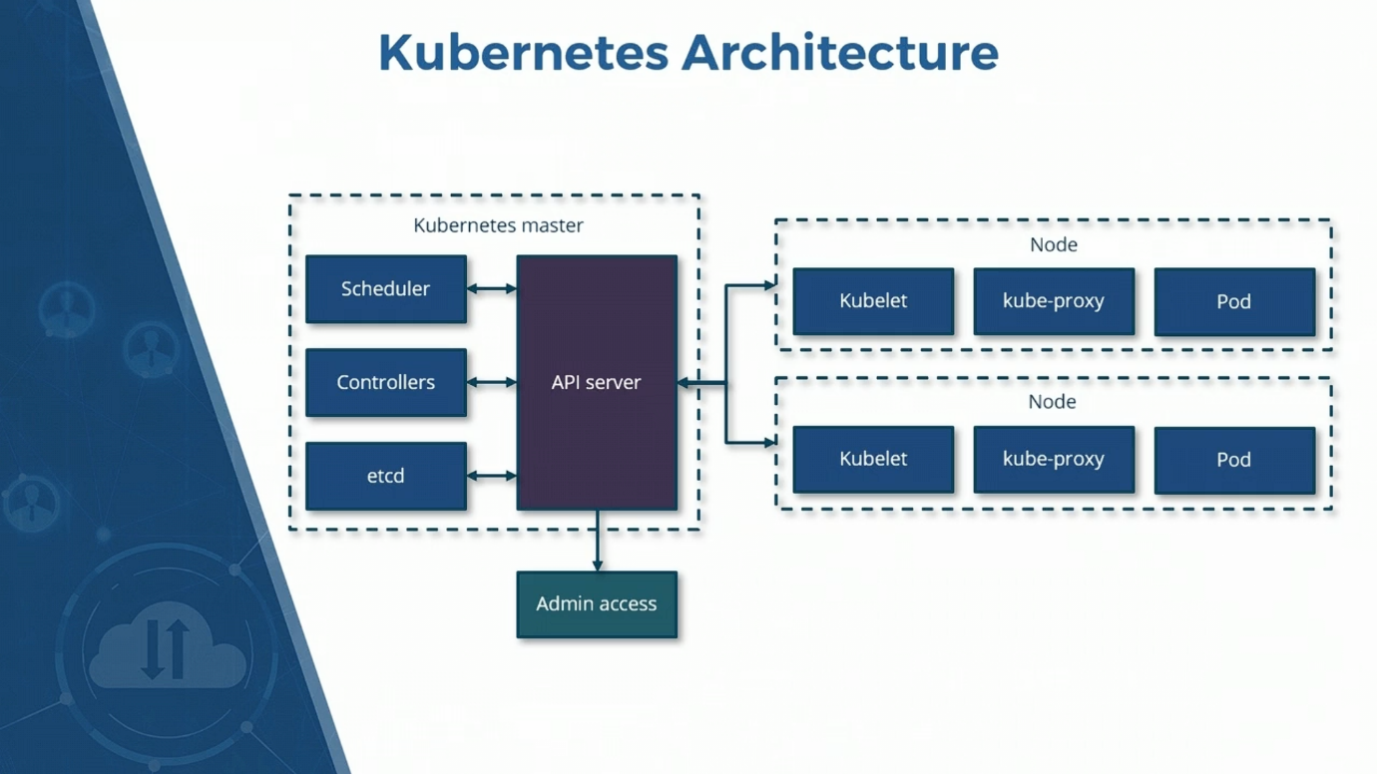

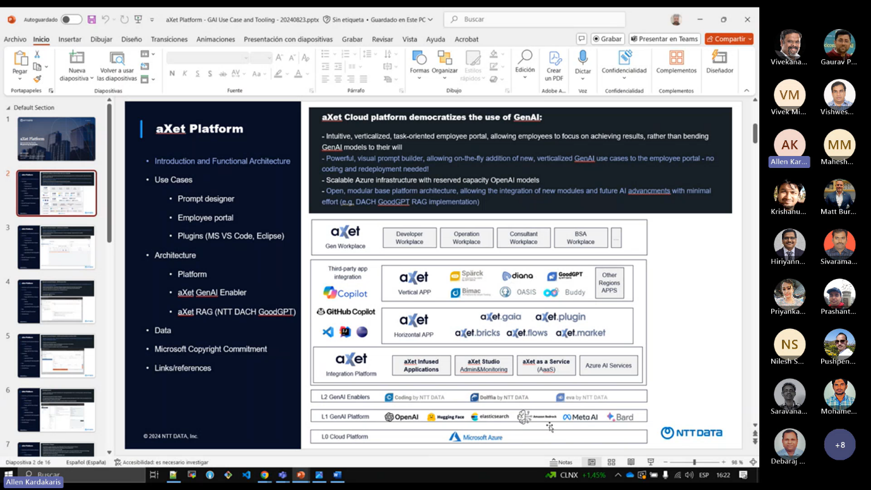

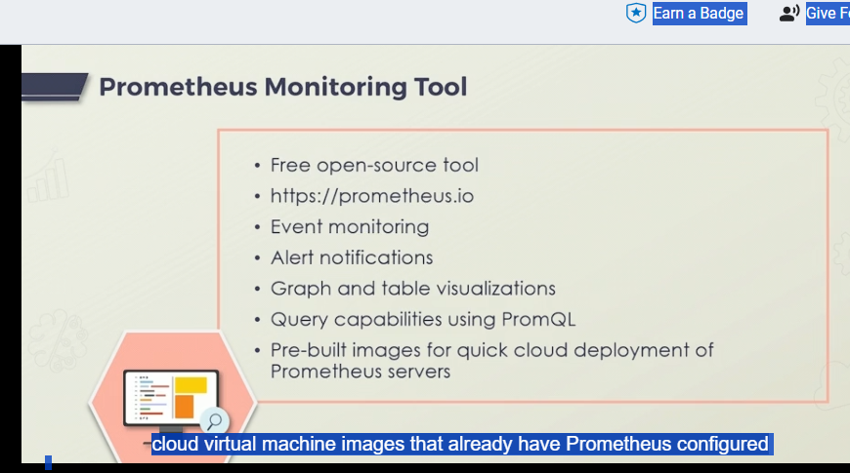

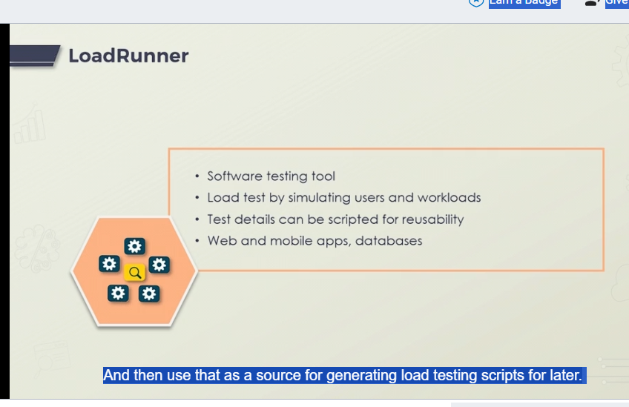

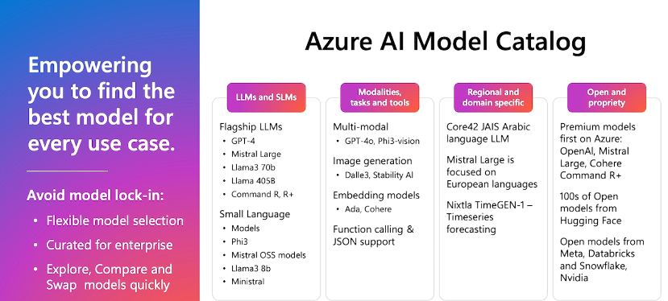

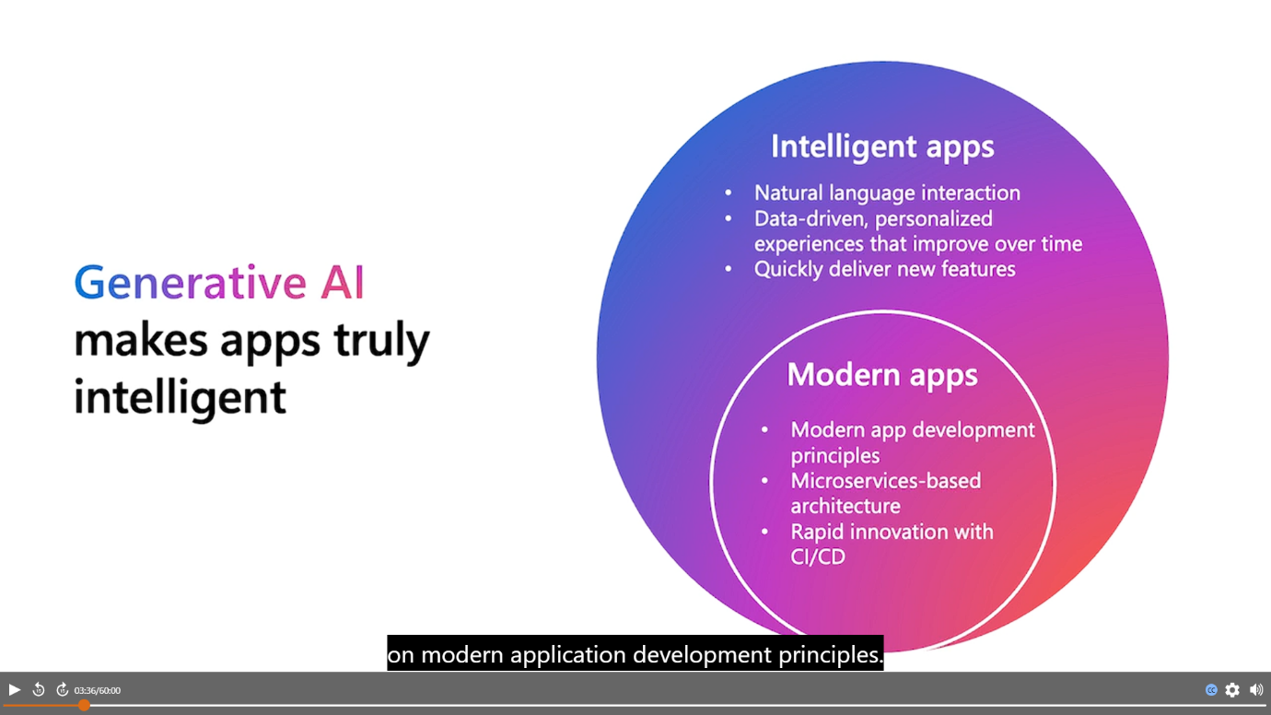

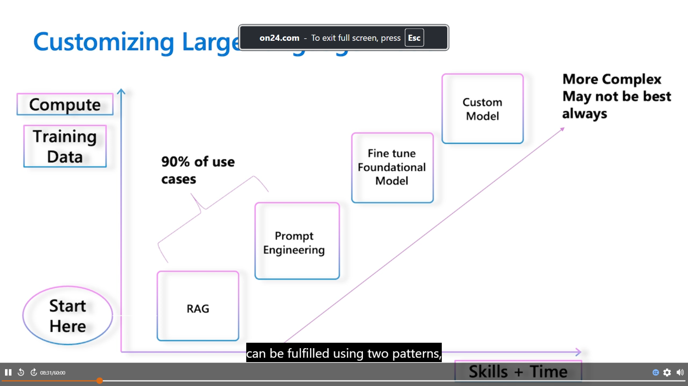

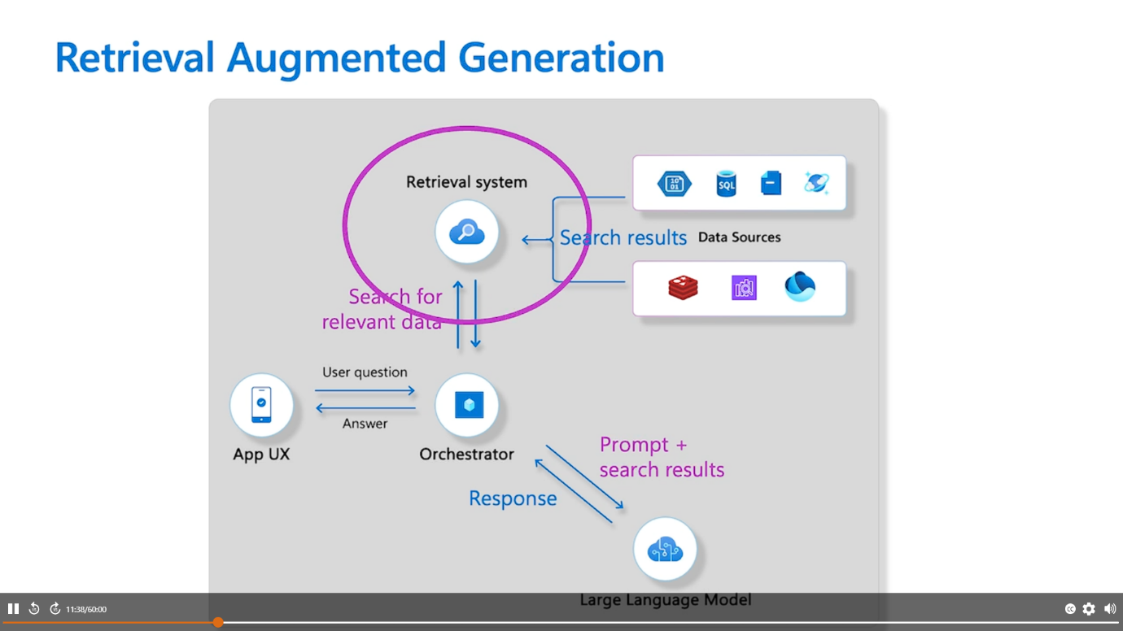

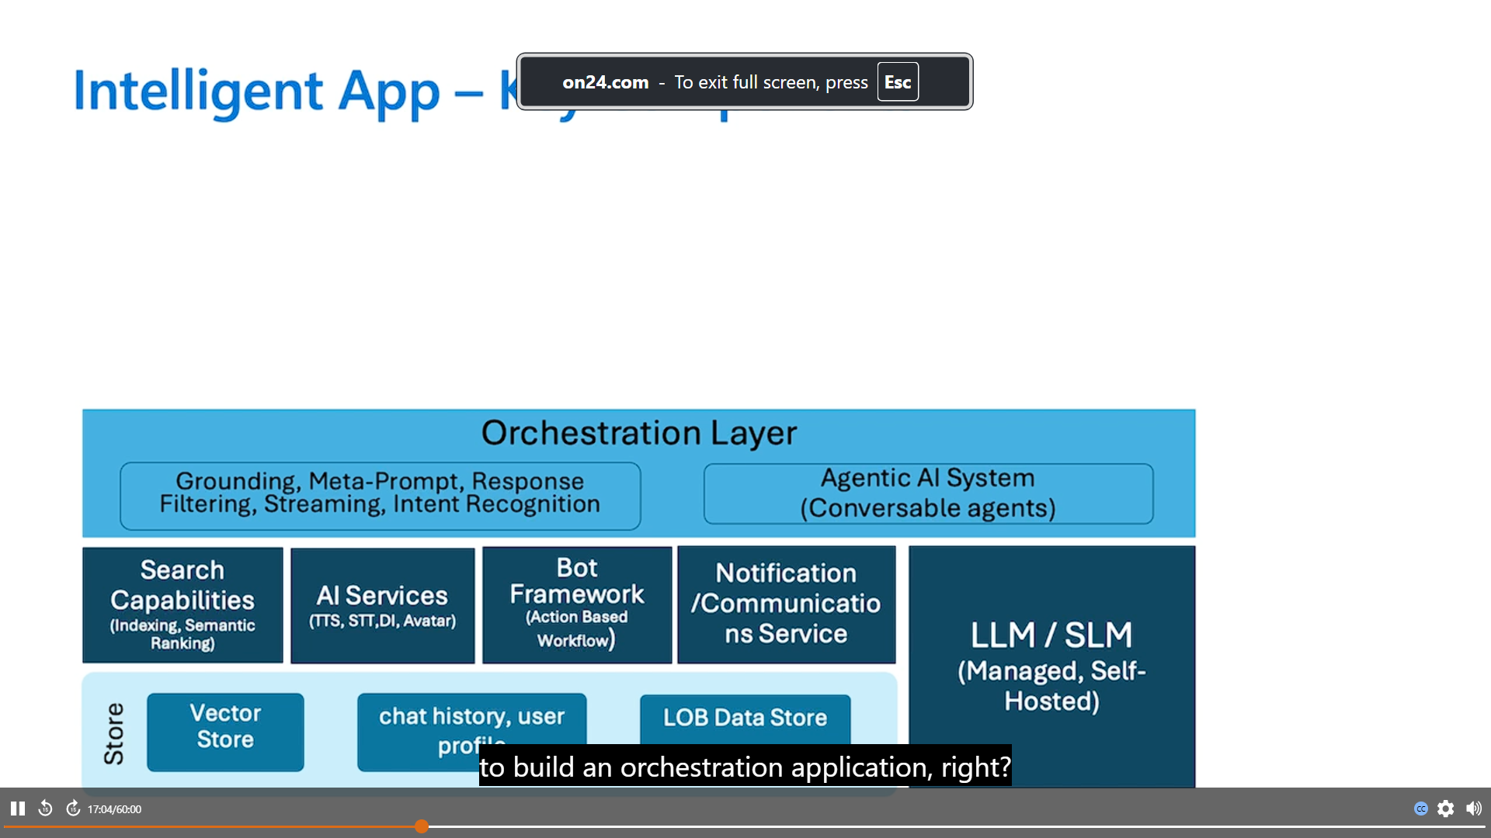

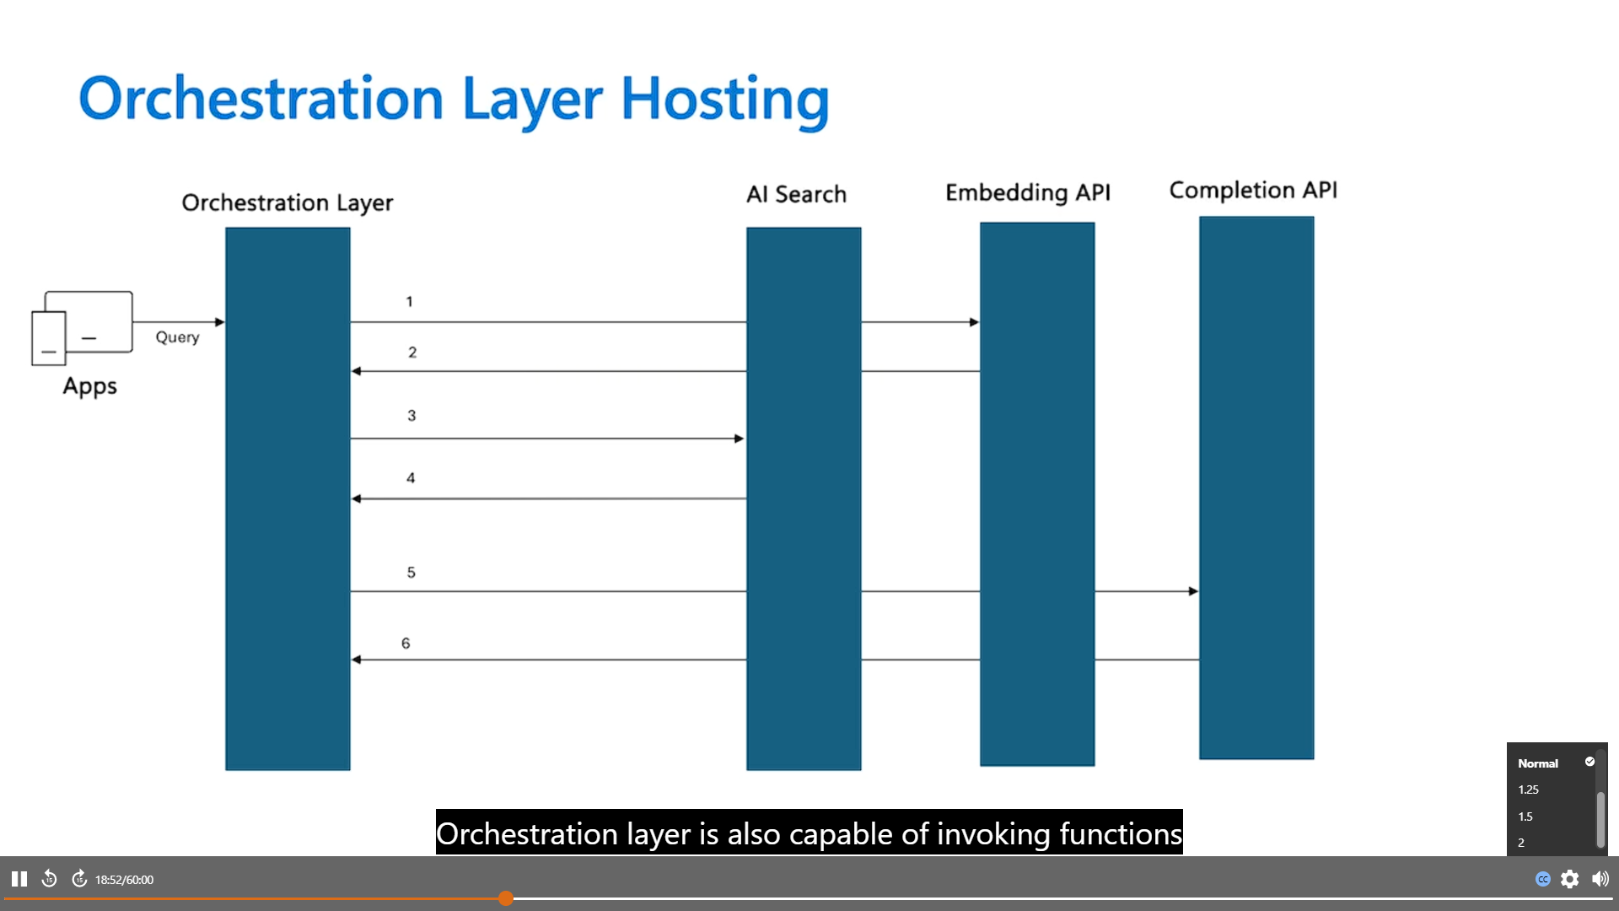

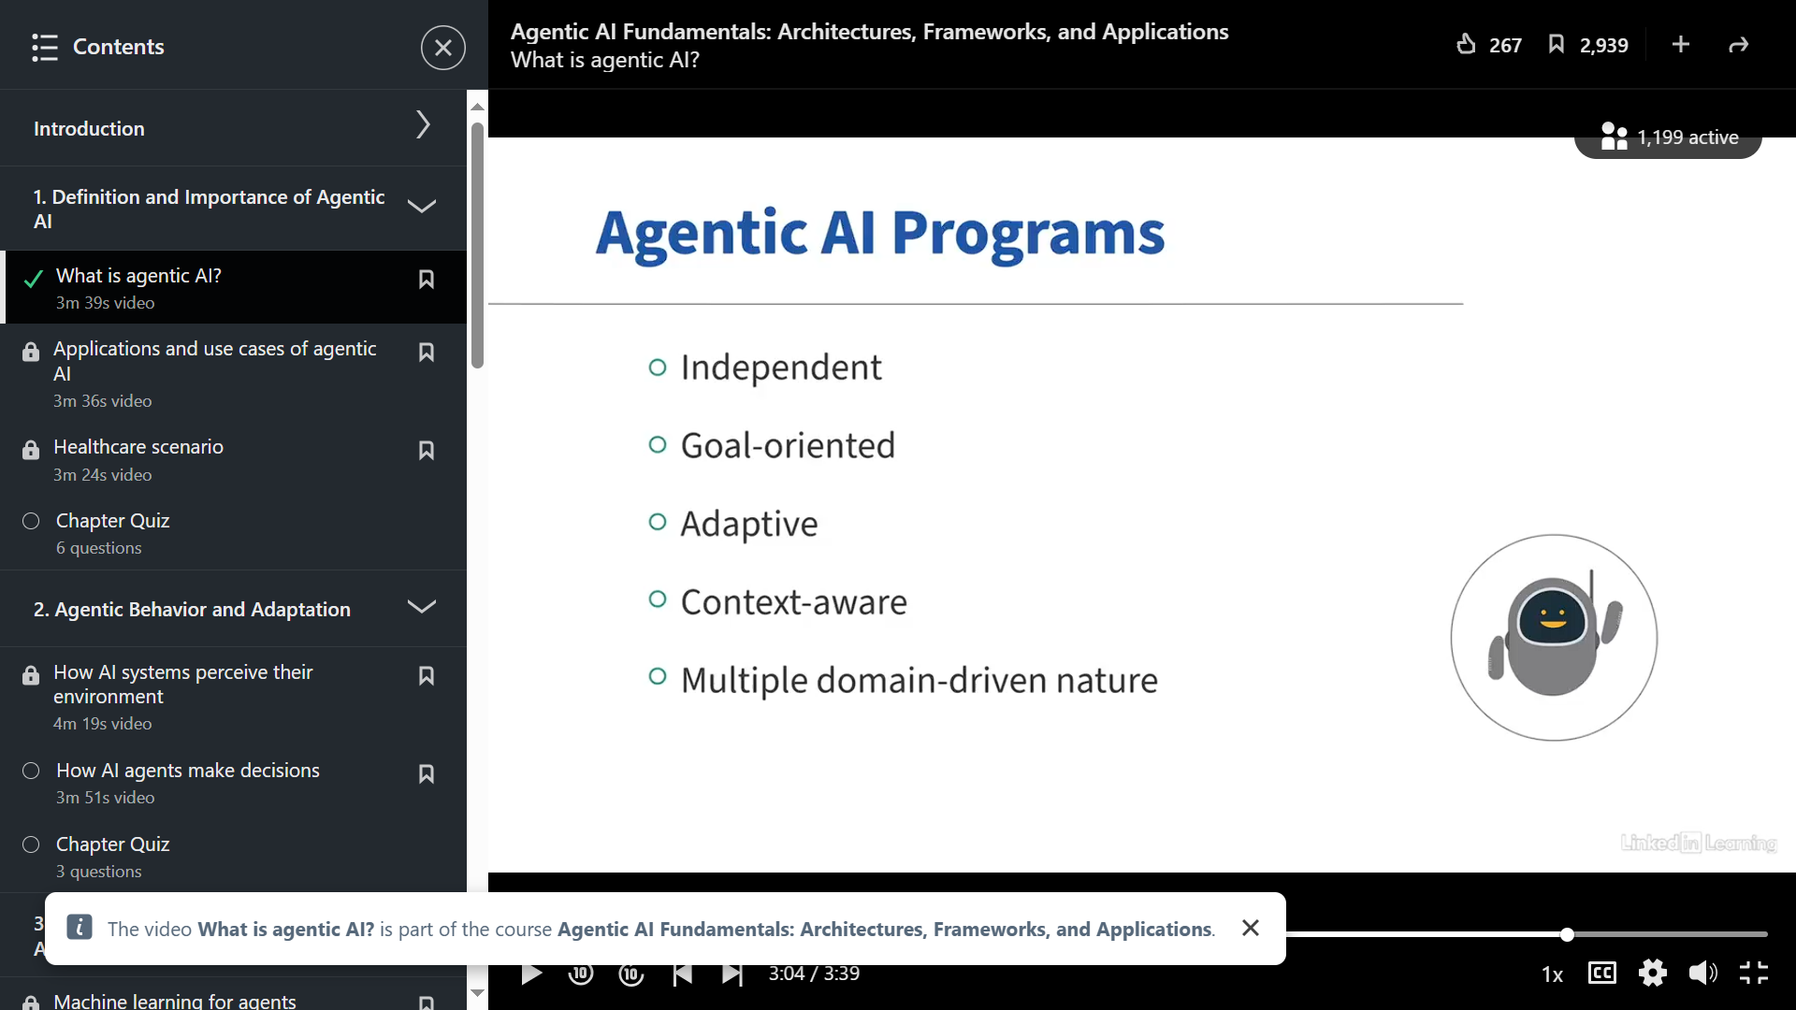

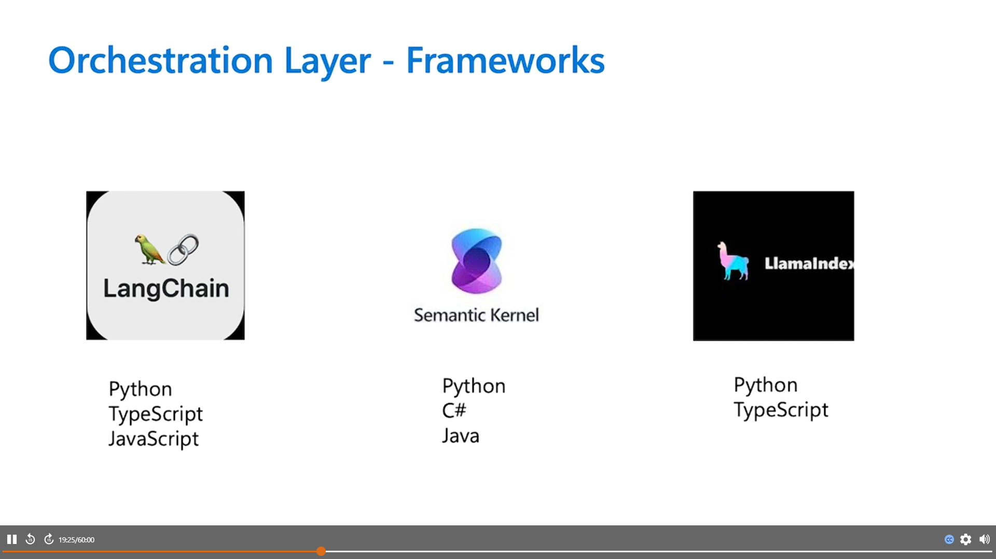

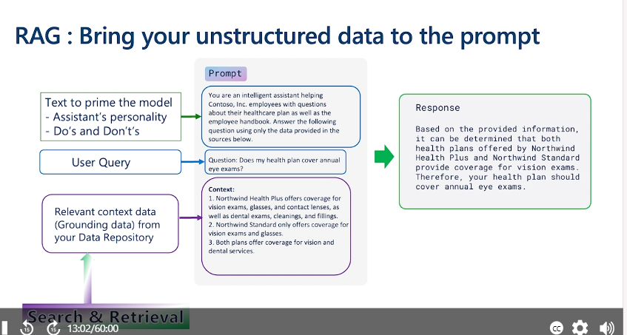

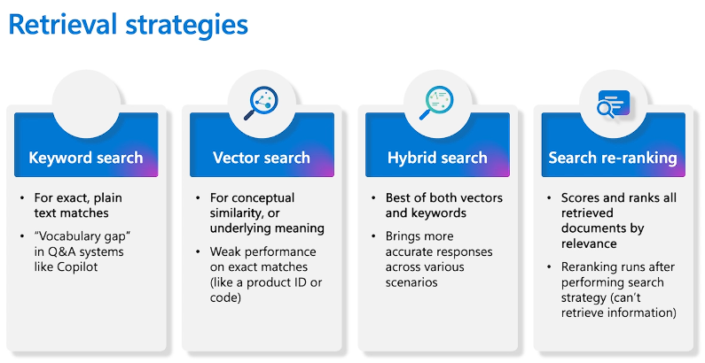

Vector Search we generate numeric representation of the text and do semantic search using conceptual similarity and multiple hit.

Retrieval Augmentation Generation

You are able to ground the response generated by the model based on your organization’s data that’s what make it intelligent app for your use case

When we interact in natural language there are multiple ways of communication

Induce various data maps/sets

